

**Software Requirements Specification  
for**  
Website For Selling & Buying Organic Fruits and Vegetables

**Website Name**

Agrocart

**Prepared by**  
Nahiyan Anwar Orko 2031163642

Mohammad Nibir Islam - 2012975042

Arpita Saha - 2011633042

Allif Laila - 2011818642

Madiha Jarrin - 20222263642

**North South University**  
**Software Engineering (CSE - 327)**

|  |  |
| --- | --- |
| **Prepared By** | **Distribution of Work** |
| Mohammad Nibir Islam 2012975042 | Introduction, Purpose, Intended Audience |
| Madiha Jarrin 20222263642 | Intended Use, Product Scope, Risk Definition |
| Nahiyan Anwar Orko 2031163642 | User Classes and Characteristics, User Needs |
| Arpita Saha- 2011633042 | Operating Environment, Constraints, Assumptions |
| Allif Laila-2011818642 | Functional Requirements, Non-Functional Requirements |

Contents

1 Introduction 4

1.1 Purpose 4

1.2 Intended Audience 4

1.3 Intended Use 4-5

1.4 Product Scope 5-6

1.5 Risk Definition 6-7

2 Overall Description 7

2.1 User Classes and Characteristics 7-8

2.2 User Needs 8-9

2.3 Operating Environment 9

2.4 Constraints 10-11

2.5 Assumptions 12-13

3 Requirements

3.1 Functional Requirements 13-15

3.2 Non Functional Requirements 16

**Introduction:**

Recently it has been quite difficult to find fresh foods in markets, especially fruits and vegetables. In this case, if the agro products can somehow be directly purchased from the farms, people may find the products fresh and without any harmful medicine applied. So Agro cart comes with the solution here. It is an e-commerce platform where farmers can directly sell their product to the end customer and, on the contrary, the customer will directly be able to order their fruits and vegetables from the farms.

**1.1 - Purpose:**

The purpose of this software is to let people be sure and confident about the agro products they are buying by letting them directly purchase from the farmers. Moreover, it aims to provide products at lesser prices by removing any third party involved between the farmers and customers. It also aims to make farmers easily handle their accounts by keeping all the transaction history online.

**1.2 Intended Audience:**

• Developers and technical team

• Customer Support team

• Quality assurance team

• Marketing team

• Farmers

•City People

**1.3 - Intended Use**

**Developers & Technical Team:** The Developers & Technical Teams use the AgroCart Platform as a canvas for their technical creativity and they build the platform with users in mind. They consider how users will interact with the platform, ensuring that it is user-friendly. They design, code, and implement various features to ensure that the platform functions seamlessly and effectively. This team built a functional, secure, and user-friendly platform that serves as the backbone of the AgroCart ecosystem. This team troubleshoots and addresses any technical issues that arise. They constantly strive to improve the platform's functionality and user experience.

**Customer Support Teams:** Customer support teams use this platform to provide assistance, answer questions, and resolve concerns that farmers and customers might have. They are the first point of contact for addressing inquiries related to products, transactions, and usage. These teams build trust, in case of disputes or disagreements between users, customer support teams act as mediators and maintain a harmonious platform environment. They play a vital role in advocating for changes that enhance the platform's functionality and user-friendliness and to ensure users have a smooth, satisfying experience.

**Quality Assurance Team:** The Quality Assurance team assesses the platform's performance to test the platform, ensure secure transactions and discover any issues or improvements. Their goal is to identify any bugs or errors that might disrupt user experience. Ultimately, the Quality Assurance team uses the AgroCart platform to raise its overall quality.

**Marketing Team:** The Marketing Team uses the platform to effectively communicate AgroCart's mission, values, and benefits.. This team launches strategic marketing campaigns to attract more farmers to join AgroCart and encourage people to choose organic food.. They educate users about the benefits of organic food and its positive impact on farmers. They aim to create a community of users who feel connected to the AgroCart brand.

**Farmers: F**armers use the AgroCart E-commerce Platform as a valuable tool to increase their sales, income, and exposure while directly engaging with customers. By setting their own prices, farmers ensure they receive fair compensation for their hard work and high-quality organic products..

**City people:** Our platformoffers city people a convenient and reliable source of fresh, organic food who prioritize their health find AgroCart appealing due to its focus on organic and pesticide-free products.

**1.4- Product Scope**

The “AgroCart” E-commerce Platform is a web-based application dedicated to connecting farmers and customers through a seamless digital marketplace. Our platform helps farmers to sell their products like fruits, veggies and fertilisers directly to customers where there's no middleman involved. So, farmers get all the money they earn. Our vision is to make things better for farmers who are going through tough times. Moreover, this innovative platform aims to promote the availability and accessibility of organic food products while supporting local farmers and providing customers with a reliable source of organic produce.

**Advantages/Benefits Offered by our Web Application:**

* **Direct Farmer-Customer Connection:** Farmers can showcase their organic produce directly on the platform, allowing customers to buy fresh and authentic organic food items.
* **Enhanced Transparency:** Customers can learn about the origins of their food, fostering a deeper connection to the farming community.
* **Convenient Shopping:** Users can effortlessly browse and purchase a variety of organic products from the comfort of their homes.
* **Support for Local Economy:** The platform empowers local farmers by providing them with a digital marketplace to showcase and sell their produce.
* **Access to Fresh Organic Produce:** Customers gain access to a diverse range of organic foods, fostering a healthier lifestyle.
* **Time Efficiency:** Saving customers time through online shopping addresses a common convenience factor sought by many consumers.
* **Reduced Food Waste:** Emphasizing the platform's role in reducing food waste aligns with sustainability goals and conscious consumer values.

**Main Objectives of Our Project are as follows:**

1. Facilitate access to fresh and authentic organic food products.
2. Encourage seasonal eating habits for improved well-being.
3. Empower local farmers by providing a digital marketplace for their produce.
4. Enhance transparency in the food supply chain and origins of products.
5. Foster community connections between consumers and local farmers.
6. Support healthier lifestyles through the availability of nutritious organic foods.
7. Strengthen local economies by promoting local businesses and agriculture.
8. Reduce environmental impact by minimizing long supply chains.

**Goals of Our Application:**

* Establishment of an all-encompassing digital marketplace connecting consumers with local farmers.
* Promotion of holistic wellness through nutritious organic food offerings.
* Reduction of ecological impact by shortening distribution cycles.
* Provision of transparent insights into the entire food supply chain.
* Provide easy access to fresh organic food.
* Establish transparency and build consumer trust.

**1.5 Risk Definition**

As we are trying to build a new platform in the marketplace. So, it's important to consider and manage various risks that might arise. Here are some possible risks definition that may be encountered:

* **Crop Failure:** Organic farming methods can be more vulnerable to pests, diseases, and weather conditions. A sudden outbreak of pests or a severe weather event could lead to significant crop loss.
* **Supply Chain Issues:** If our project involves sourcing organic ingredients from multiple suppliers, there's a risk of disruptions in the supply chain. Any issues with suppliers could impact on your ability to produce and deliver products.
* **Technical Challenges:** Unforeseen technical issues during development that could hinder progress or compromise platform functionality.
* **Quality Control:** Maintaining consistent quality standards in organic production can be challenging. Inconsistent quality could lead to customer dissatisfaction and harm your brand reputation.
* **Market Viability:** Uncertainty about the platform's acceptance and adoption by consumers and farmers, potentially affecting user engagement.
* **Vendor Relationships:** Challenges in maintaining positive relationships with local farmers, impacting product quality and variety.
* **Environmental Issues:** Climate-related events or natural disasters affecting agricultural production and product availability.
* **Competition:** New entrants and established brands can pose a challenge in terms of pricing, marketing, and differentiation. Moreover, Competition from existing platforms or local retailers impacting the platform's market share.

**2: Overall Description:**

The platform that we are trying to build is a completely new platform in the market. It’s an E-commerce platform named “AgroCart”, that lets the farmers to sell their products such as, organic fruits, vegetables, fertilizers etc. directly to the customers. There won’t be any 3rd party involved between the farmer and the customer. So, the farmer will be able to take the entire profit.  
As a result, the problems regarding the farmers getting ‘unfair price of produce’ & ‘insufficient funds’ will be solved. Our platform focuses on the crisis that the farmers are facing and tries to solve the crisis.

**2.1: User Classes and Characteristics:**

There are 3 user-classes on our platform. They are:

i. Farmer-Seller

ii. Customer

iii. Admin

The Characteristics of these user classes are given below: -

***User Class 1:*** Farmer - Seller

**Seller Profile:** Farmers who want to sell agricultural products on the platform.

**Product Listings:** Can create and manage listings for their products, including details like product name, description, price, and quantity.

**Inventory Management:** Have the ability to update and track their product inventory.

**Order Management:** Can view and manage orders placed for their products.

**Communication:** May need to communicate with customers regarding product inquiries, delivery, and order updates.

**Payment:** Receive payments for their sold products, usually through the platform's payment system.

**Ratings and Reviews:** May receive ratings and reviews from customers for their products and services.

***User Class 2:*** Customer

**Customer Profile:** Individuals or businesses looking to purchase agricultural products from the platform.

**Browsing and Searching:** Can search for products, view product details, and browse categories.

**Shopping Cart:** Can add products to their shopping cart for later purchase.

**Order Placement:** Can place orders, select delivery options, and make payments.

**Account Management:** Have the ability to manage their user profile, including address, payment methods, and order history.

**Ratings and Reviews:** Can leave ratings and reviews for products and sellers based on their experiences.

**Customer Support:** May need to contact customer support for inquiries, order issues, or product information.

***User Class 3:*** Admin

**Administrative Role:** Has administrative privileges and responsibilities on the platform.

**User Management:** Can manage user accounts, including verifying sellers and handling account-related issues.

**Product Management:** Can oversee and moderate product listings to ensure compliance with platform policies.

**Order Management:** Manages and monitors orders, including resolving disputes and issues.

**Analytics and Reporting:** Accesses platform data and generates reports for performance analysis and decision-making.

**Content Management:** Controls and updates platform content, such as announcements, policies, and FAQs.

**Security and Compliance:** Ensures platform security, compliance with regulations, and data protection.

**Technical Support:** Provides technical support to both sellers and customers as needed.

These are the characteristics of the user-classes on our platform. The Use Case diagram of our platform is given below.

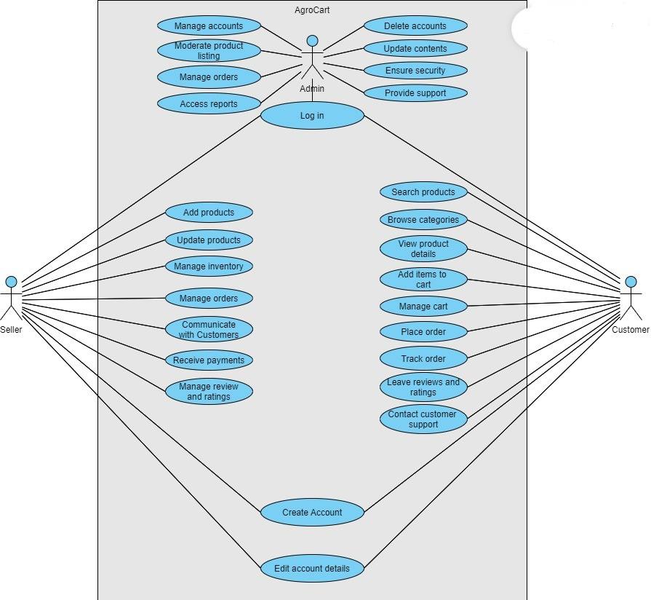

**2.3: OPERATION ENVIRONMENT:**

**Supported Devices and Browsers:**

1. The platform should be accessible through various devices, including desktop computers, laptops, tablets, and smartphones.

2. Compatibility with popular web browsers (Google Chrome, Mozilla Firefox, Safari, Microsoft Edge) should be ensured.

**Network Requirements:**

1. The platform should be accessible over standard internet connections.

2. Secure sockets layer (SSL) encryption must be implemented to ensure data security during transmission.

**2.4: CONSTRAINTS:**

**1. User Roles and Permissions:**

Farmers: Should be able to create and manage their profiles, list products, set prices, manage inventory, and interact with customers.

Customers: Should be able to browse products, place orders, make payments, provide feedback, and track order status.

Admin: Should have control over the platform, including user management, content moderation, and dispute resolution.

**2. Geographic Scope:**

Specify the regions where the platform will be available. This could be at a city, state, national, or international level.

**3. Product Categories:**

Define the types of organic products that can be listed (fruits, vegetables, herbs, etc.) and any specific subcategories.

**4. Inventory Management:**

Set constraints on the maximum and minimum quantity of products that farmers can list.

Define rules for updating inventory levels when products are sold.

**5. Product Quality Standards:**

Specify guidelines for organic certification and quality standards that farmers need to meet.

**6. Payment Methods:**

Determine which payment methods will be supported (credit/debit cards, digital wallets, bank transfers, etc.).

Ensure the platform complies with relevant payment security standards.

**7. Delivery Options:**

Define whether farmers will handle their own deliveries or if there will be a separate delivery service.

Specify delivery areas and associated costs.

**8. Reviews and Ratings:**

Define rules for customers to leave reviews and rate products.

Specify any moderation process for managing fake or inappropriate reviews.

**9.User Communication:**

Specify how users will communicate, such as through messaging, chat, or email.

**10. Technical Constraints:**

Specify the preferred technology stack for development (programming languages, frameworks, databases, etc.).

**11. Security:**

Specify security measures to protect against hacking, data breaches, and unauthorized access.

**12. Legal and Regulatory Compliance:**

Ensure the platform complies with relevant laws and regulations related to e-commerce, organic product sales, and taxation.

**13. Support and Maintenance:**

Define the support mechanisms for users and how ongoing maintenance and updates will be handled.

**2.4: ASSUMPTIONS:**

**1. Organic Certification Validity**-Farmers listing products on the platform are assumed to possess valid organic certifications according to the relevant local or international organic standards.

**2. Product Availability-**It is assumed that the availability of organic products listed on the platform is subject to variations due to seasonal factors, weather conditions, and other unforeseen circumstances affecting agricultural production.

**3. Farmer Product Listings-**Farmers are responsible for accurately listing product details, prices, descriptions, and images on the platform.

**4. Product Quality-**Customers assume that products listed as "organic" meet defined quality standards. Any disputes related to product quality will be handled through the platform's dispute resolution process.

**5. Customer Authentication-**Customers are assumed to provide accurate and authentic personal information during the registration and checkout processes.

**6. Payment Security-**It is assumed that the platform will implement industry-standard security measures to protect customers' payment information during transactions.

**7. Third-Party Payment Processors-**The integration of third-party payment processors assumes compliance with their terms of service and any potential transaction fees.

**8. Delivery-**Delivery times and conditions are based on standard shipping practices. Any deviations or delays due to unforeseen circumstances will be communicated to customers.

**9. Product Images-**Product images provided by farmers are assumed to accurately represent the actual products being sold.

**10. Privacy and Data Protection-**The platform assumes compliance with data protection regulations to ensure the privacy and security of user information.

**11. Platform Maintenance-**Routine maintenance, updates, and bug fixes are assumed to be necessary for the platform's optimal functioning and user experience.

**12. User Reviews and Ratings-**Customers are expected to leave honest and fair reviews and ratings based on their actual experiences with the products.

**13. Regulatory Compliance-**The platform assumes adherence to relevant e-commerce, taxation, and organic product sales regulations.

**14. Language and Content-**The platform assumes users will interact in the supported languages and that content provided by users adheres to acceptable language and content standards.

**16. Mobile Responsiveness**-The platform assumes users will access the site from various devices, and the user experience will be optimized for mobile devices.

**17. Support**-Basic user support is assumed to be available to address common issues and inquiries.

**3.1: Functional Requirement:**

**1: Customer Registration**

As a potential customer, I want to create an account on the e-commerce website, So that I can start browsing and purchasing organic fruits and vegetables directly from farmers.

*Requirements:*

* The registration process should require users to provide their name, email address, password, and contact information.
* Users should receive a verification email upon registration to confirm their email address.

**2: Browse Products**

As a customer, I want to view a list of available organic fruits and vegetables, So that I can choose what items I want to purchase.

*Requirements:*

* The homepage should display a grid of available organic products, including images, names, and basic details.
* Users should be able to filter and sort products based on categories, prices, and other relevant attributes.

**3: View Product Details**

As a customer, I want to see detailed information about a specific organic product (such as price, weight, and description), So that I can make an informed decision about whether to purchase it.

*Requirements:*

* Each product's detailed view should include its price, weight, description, images, and any certifications (e.g., organic, non-GMO).
* Customers should be able to see reviews and ratings for the product if available.

**4: Add to Cart**

As a customer, I want to add selected organic products to my shopping cart, So that I can keep track of the items I intend to purchase.

*Requirements:*

* Users should be able to easily add a selected quantity of a product to their shopping cart.
* The shopping cart icon should display the current number of items in the cart.

**5: Adjust Quantity in Cart**

As a customer, I want to be able to adjust the quantity of items in my shopping cart, So that I can change the number of products I want to buy.

*Requirements:*

* Customers should be able to change the quantity of items directly from the shopping cart page.
* The cart total should be updated dynamically as the user adjusts quantities.

**6: Checkout Process**

As a customer, I want to proceed to the checkout process from my shopping cart, So that I can finalize my purchase.

*Requirements:*

* During checkout, users should be prompted to confirm their shipping address and preferred delivery method.
* An order summary should be displayed before payment for review.

**7: Multiple Payment Options**

As a customer, I want to be able to choose from various payment options (credit card, bkash, COD, etc.), So that I can complete my purchase using my preferred method.

*Requirements:*

* The website should integrate with a secure payment gateway to handle credit card and online payment processing.
* Users should be able to select their preferred payment method during checkout.

**8: Farmer Registration**

As a farmer, I want to create an account on the e-commerce website as a seller, So that I can list and sell my organic fruits and vegetables directly to customers.

*Requirements:*

* The farmer registration process should include verification of the user's status as a farmer.
* Farmers should be required to provide additional information, such as farm name and location.

**9: List Products for Sale**

As a farmer, I want to list my organic products with details like price, weight, and description, So that customers can see and purchase them.

*Requirements:*

* Farmers should be able to add products for sale, including images, names, descriptions, prices, and quantities.
* Farmers should have the ability to edit or remove listed products as needed.

**10: Admin Maintenance**

As an admin, I want to have access to a backend dashboard for website maintenance and security, So that I can ensure the smooth operation of the platform.

*Requirements:*

* The admin dashboard should allow administrators to manage user accounts, product listings, and orders.
* Security measures like user authentication and authorization should be in place to protect the admin panel.

**11: Secure User Data**

As a customer or farmer, I want to be assured that my personal and payment information is secure So that I can use the platform without concerns about privacy.

*Requirements:*

* User data, especially payment information, should be encrypted during transmission and storage.
* The website should adhere to industry standards for data security and privacy.

**12: Freshness Guarantee**

As a customer, I want to be assured that the organic fruits and vegetables I purchase are fresh So that I can enjoy high-quality produce.

*Requirements:*

* Farmers should provide information about their harvesting practices and estimated delivery times.
* The website should provide a guarantee of freshness upon delivery.

**13: Feedback and Ratings**

As a customer, I want to provide feedback and ratings for products I've purchased, So that other customers can make informed decisions, and farmers can improve their offerings.

*Requirements:*

* Customers should be able to leave reviews and ratings for products they've purchased.
* Farmers and customers should have the ability to respond to reviews and address any concerns.

**3.2: Non-Functional Requirement:**

**Performance:**

* The website should load within 3 seconds on a standard internet connection.
* The platform should handle a simultaneous load of at least 500 users without significant degradation in response time.
* Search and filtering functionalities should provide real-time results with minimal delay.
* Page transitions and interactions should feel smooth and responsive on both desktop and mobile devices.

**Safety:**

* User data, including personal information and payment details, must be encrypted using secure protocols (HTTPS).
* Passwords should be securely hashed before storage.
* The platform should have measures in place to prevent SQL injection and other common security vulnerabilities.
* Farmers' and customers' data must be kept confidential and protected from unauthorized access.

**Security:**

* The platform must employ secure authentication mechanisms for users, requiring strong password updates.
* Farmers should only be able to modify their own product listings and data.
* Customers should only have access to their own order history and personal information.
* Admin privileges should be tightly controlled and require strong authentication.

**Quality:**

* The platform's user interface should be visually appealing and provide a positive user-friendly experience.
* All links and interactive elements should be functional and not lead to broken pages.
* The platform should be free of spelling and grammatical errors.
* Automated tests should cover critical functionalities, including registration, login, order placement, and payment processing.